

WHITEFIELD, BANGALORE

INCLUSION POLICY
Policy Information | Details
Document No.: Inclusion Policy 2023 | Revision No. 2
Prepared by: Head of School,DP Coordinator, MYP Coordinator, PYP Coordinator, SEN teachers and Behaviour Counselor | First Preparation Date: June 2023  Revision No. 1 January 2025
Approved by: Head of School | Last review date: August 2026
Next review: August 2028 | Review cycle: Once every two years

OWIS Mission
At One World International School, our mission is to develop inquiring, compassionate and reflective lifelong learners who respect all cultures and care for our world. We believe every child should have equitable access to best-in-class, future-proofed education.

OWIS Vision
OWIS aspires to be a leader in providing world-class quality and affordable education to all students, with an emphasis on values, collaboration, creativity and service to others.

Alignment with the IB Mission
The IB aims to develop inquiring, knowledgeable and caring young people who help to create a better and more peaceful world through intercultural understanding and respect. IB programmes encourage students to become active, compassionate and lifelong learners who understand that other people, with their differences, can also be right.
The OWIS mission and vision strongly reflect these principles. This alignment is particularly significant within the Inclusive Education Policy, which seeks to ensure that every learner is valued, respected and provided equitable opportunities to participate, learn and demonstrate progress. Inclusion at OWIS focuses on identifying and removing barriers, responding positively to individual needs, valuing prior knowledge and identity, and creating supportive learning environments across the continuum.
The policy promotes international-mindedness and the development of ATL skills, enabling students to understand and appreciate diverse perspectives, communicate effectively, reflect on their learning and take responsible action.

Inclusive practice is therefore understood as a shared responsibility across teaching, learning, assessment, student wellbeing and school–home partnerships. It supports the development of confident, caring, principled, reflective and balanced learners who can participate meaningfully in their learning community.
International-Mindedness and ATL in Practice
The Inclusion Policy promotes international-mindedness by creating a learning environment in which diversity is recognised, respected and valued. Students are encouraged to appreciate different identities, experiences, perspectives and ways of learning, and to contribute positively to an inclusive community.
Inclusive classroom practices provide opportunities for students to develop social, communication, self-management and thinking skills. Through collaboration, reflection and meaningful participation, students learn to understand different perspectives, demonstrate empathy and take responsibility for creating a respectful learning environment.

2. IB Learner Profile and Inclusive Education
Learner Profile Attribute | Inclusive Education in Practice
Inquirers | Curious learners who develop skills for inquiry and research and learn independently and collaboratively.
Knowledgeable | Learners who develop conceptual understanding and engage with knowledge and ideas of local and global significance.
Thinkers | Learners who use critical and creative thinking and make reasoned, ethical decisions.
Communicators | Learners who express themselves confidently and creatively, listen to others and collaborate effectively.
Principled | Learners who act with integrity, honesty and fairness and take responsibility for their actions.
Open-Minded | Learners who appreciate their own cultures and those of others and are willing to consider different perspectives.
Caring | Learners who demonstrate empathy, compassion and respect and act to make a positive difference.
Risk-Takers | Learners who approach uncertainty with determination, resourcefulness and resilience.
Balanced | Learners who understand the importance of intellectual, physical and emotional wellbeing and interdependence.
Reflective | Learners who thoughtfully consider their experiences, strengths and areas for development.

3. Policy Statement and Philosophy
Inclusion is a process that aims to increase access and engagement in learning for all students by identifying and removing barriers. It responds positively to each individual's unique needs and seeks to avoid marginalising students because of their differences.
OWIS believes that education should nurture the whole child. Courage, character, creativity and competence are important dimensions of development, while self-esteem and self-worth are valued beyond performance in assessment. Affirming identity, valuing prior knowledge and creating a supportive environment are central to successful inclusion.
OWIS recognises and appreciates the diverse learning needs of students and is committed to providing appropriate support and encouragement. Inclusive education is a shared responsibility of the school community.
Inquiry-based, student-centred and collaborative approaches provide opportunities for learners to engage at different paces and through varied pathways. Teachers use differentiated instruction, assessment and home-learning opportunities to respond to diverse needs.

4. Inclusive Education Across the OWIS Continuum
OWIS is committed to maintaining a consistent and inclusive approach from Early Years through the Diploma Programme. The nature of support develops with students' age, independence and programme expectations.
Programme | Key Approach | Examples of Support | Assessment / Access
EYP | Play-based, child-centred and observational | Language development, individualised support, flexible environments, observation and responsive interactions | Developmentally appropriate evidence and varied ways to participate
PYP | Inquiry-based, differentiated and student-centred | Flexible grouping, scaffolding, varied resources, language-sensitive approaches and targeted support | Varied assessment strategies and accessible learning experiences
MYP | Increasing independence and explicit support | Differentiated teaching, intervention, learning strategies and collaboration with support staff | Accessible tasks, differentiated pathways and appropriate accommodations
DP | Equitable access with increasing independence | Differentiated teaching, reasonable accommodations and IB-approved access arrangements where required | Programme/examination requirements and approved access arrangements

5. Identification and Support from Admission to Classroom Inclusion
Inclusive practice begins at admission and continues through classroom participation, monitoring and review.
- During admissions and induction, relevant oral, written and student information is collected and maintained for appropriate educational reference.
- Where learning gaps or support needs are identified, parents/guardians are involved in understanding the learner's needs and planning appropriate support.
- Where a student has a known history of additional learning or support needs, relevant staff, including school leadership, the special educator/counsellor and year-level teachers, collaborate with parents/guardians to understand the learner.
- Teachers use observations, prior-learning information, classroom evidence and appropriate diagnostic processes to identify areas requiring further support.
- Where required, external professional input may be sought to inform assessment, intervention or support planning.
- Admission decisions are made with consideration of the school's capacity to provide the support required for the student's successful participation and learning.

6. Responding to Diverse Learning Needs
The school recognises that learners may require different forms or levels of support. The following areas are identified in the existing policy and are considered when planning provision:
- Specific Learning Difficulties (SLD), including difficulties that may affect reading, writing, spelling, language processing or mathematical calculation.
- Gifted and talented learners who demonstrate, or have the potential to demonstrate, exceptional abilities in particular areas, disciplines or interests.
- Language and communication needs that may affect speech, language or communication.
- Emotional, social and behavioural needs that may affect participation, learning or relationships.
Identification of a need is followed by appropriate observation, consultation and support planning. The purpose is to reduce barriers and enable meaningful participation rather than to define students by a label.

7. Facilitating Inclusive Learning
OWIS aims to create a harmonious and positive learning climate in which students feel emotionally, socially and physically safe.
- Teachers provide differentiated learning opportunities and materials appropriate to students' interests, readiness and abilities.
- Differentiation may be planned through content, process, product and learning environment.
- Individual progress is considered an important indicator of success alongside curriculum expectations.
- Flexible grouping, cooperative learning and student-centred approaches are used to provide different pathways into learning.
- Teachers use varied teaching, learning and assessment strategies so that students have equitable opportunities to demonstrate understanding.
- A resource/special education provision is available for students who require targeted support.
- Where appropriate, assistive or alternative ways of accessing learning and responding to tasks are considered.

8. Individualised Support and Intervention
Following assessment or identification of additional needs, an Individualised Education Plan (IEP) or other appropriate support plan may be maintained where required.
- Identify priority learning, developmental, social or emotional needs.
- Set appropriate and achievable goals.
- Identify strategies, accommodations and interventions.
- Clarify roles of classroom teachers, support staff and parents/guardians.
- Monitor progress and review the effectiveness of strategies.
- Adjust support as the learner's needs and level of independence develop.
Individual case records are maintained where required to document relevant support, progress and follow-up. Information is handled responsibly and shared only with those who need it to support the learner.

9. Inclusive Assessment Practices
Assessment is designed to provide equitable opportunities for students to demonstrate their learning. Teachers differentiate formative and summative assessment where appropriate and use a range of strategies and tools according to students' needs.
- Use varied modes of response and opportunities to demonstrate understanding.
- Provide appropriate scaffolding, clarification and access to resources where these do not compromise the intended learning outcome.
- Consider reasonable adjustments to format, instructions, timing, environment or mode of response where appropriate.
- Monitor whether language, access or other barriers are preventing a student from demonstrating intended learning.
- Use evidence from multiple sources rather than relying on a single task where appropriate.
- For external examinations and IB assessments, follow the applicable board/IB requirements and approved access arrangements.

10. Roles and Responsibilities
Role | Key Responsibilities
School Leadership | Establish an inclusive culture; ensure appropriate resources and staffing; review implementation; support professional learning and recruitment according to need.
Programme Coordinators / Heads | Coordinate inclusive practices within the programme; support teachers; monitor provision; facilitate collaboration and continuity across transitions.
Teachers | Know learners and their needs; gather evidence; plan differentiation; monitor progress; collaborate with support staff; communicate with parents/guardians; refer concerns when further support is required.
Special Educator / Learning Support | Support identification of learning needs; advise teachers; contribute to individualised planning; observe learners; provide targeted support; monitor and review progress.
Counsellor / Wellbeing Team | Support social and emotional wellbeing; provide individual or group support as appropriate; collaborate with teachers and families; maintain appropriate confidentiality; refer for external support when needed.
Students | Participate actively in learning, communicate their needs where possible, use agreed strategies, reflect on progress and develop increasing independence.
Parents / Guardians | Share relevant information, participate in planning and review, support agreed strategies and maintain communication with the school.

11. Culture of Learning, Wellbeing and Student Agency
OWIS seeks to create a culture in which students, teachers and parents/guardians can thrive in a positive learning climate. Students are encouraged to develop learning agency and understand themselves as active participants in their learning.
The Counseling and Wellness provision supports students' social and emotional wellbeing and provides a safe, supportive space within the school environment. Support may include individual or group sessions, classroom observations, social-skills guidance, behaviour support and collaboration with families and teachers.
The school recognises that intellectual, physical, social and emotional development are interconnected. Acceptance, trust, respect and appropriate confidentiality are central to supportive relationships.

12. Referral, Recording and Reporting
The school uses appropriate documentation to support consistent identification, intervention, communication and review. Depending on the nature of the concern, records may include:
- Teacher referral form for academic, behavioural or emotional concerns.
- Student/classroom observation records.
- Learning checklists or diagnostic information.
- Individualised education/support plans.
- Parent/guardian interaction records and agreed action plans.
- Relevant student progress and intervention records.
- Counselling documentation, including consent and case formulation, where applicable.
Student progress is monitored periodically by teachers and/or support staff. Where appropriate, parents/guardians receive updates and are involved in reviewing goals and next steps.
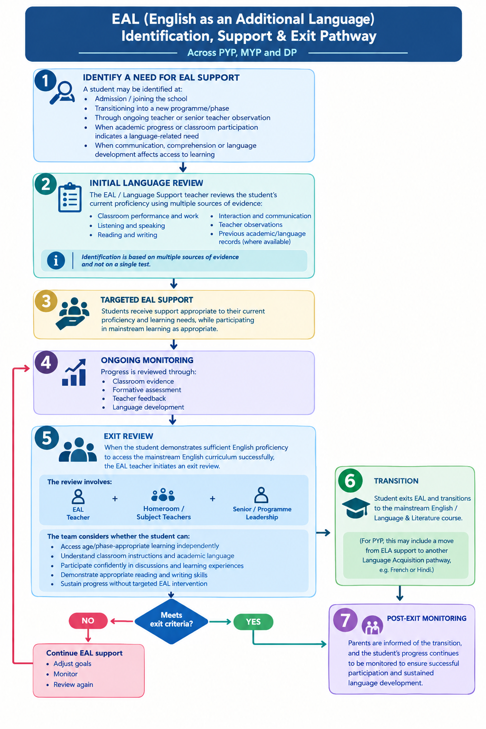

13. Inclusive Education in the Diploma Programme
OWIS Whitefield is committed to providing an inclusive and supportive learning environment for DP students. The school recognises diverse learning needs, abilities, backgrounds and individual circumstances.
- Appropriate differentiated teaching and learning strategies are provided where required.
- Reasonable accommodations are considered to ensure equitable access to the curriculum and assessment.
- Teachers, the DP Coordinator, learning support team and parents/guardians collaborate to identify needs, monitor progress and plan interventions.
- IB-approved access arrangements are followed where required for formal IB assessments.
- Support is provided while maintaining student dignity, independence and academic integrity.

14. External Examinations and Access Arrangements
Where students require accommodations for external examinations, the school follows the requirements of the relevant examination board or programme. Requests and supporting documentation are submitted through the appropriate school/external assessment process within the required timelines. For IB assessments, current IB procedures and approval requirements take precedence.

15. Collaboration and Professional Learning
Inclusive education is strengthened through regular collaboration between classroom teachers, programme leadership, special educators/learning support, counsellors and parents/guardians.
- Year-level/programme teams collaborate on curriculum, assessment, differentiation and student progress.
- Teachers seek guidance from specialist staff when a learner's needs require additional expertise.
- Staff use observations and evidence to review the effectiveness of support strategies.
- Professional learning is provided or identified according to student and staff needs.

16. Monitoring, Review and Continuous Improvement
A committee comprising school leadership, programme coordinators, counselling/wellbeing representatives, support staff and teachers periodically reviews the implementation of this policy. The review considers student needs, effectiveness of support, staffing and resources, programme requirements and feedback from relevant stakeholders.
The school may strengthen staffing, specialist provision or professional learning according to identified needs. The policy is reviewed regularly to ensure that it remains relevant, practical and aligned with the school's mission and applicable IB programme expectations.

17. Connections with Other OWIS Policies
- Assessment Policy – inclusive assessment provides equitable opportunities for students to demonstrate learning and informs differentiation and intervention.
- Language Policy – language development and language-sensitive approaches support access to learning and communication.
- Academic Integrity Policy – accommodations and support must preserve the authenticity and integrity of student learning and assessment.
- Student Wellbeing / Safeguarding provisions – inclusion is supported by emotional, social and physical safety.
- Admissions Policy – relevant information gathered at admission informs induction, transition and appropriate support.

18. Policy Control
Developed / Adopted | July 2023
Reviewed | August 2024; February 2025; September 2026
Next Review | September 2027
Responsible Team | School Leadership, Programme Coordinators and Inclusion Team

19. References
The original policy references IB programme guidance on learning diversity and inclusion. The policy should be read alongside current IB programme documentation and relevant school policies. Where current programme or examination requirements differ from this document, the applicable current IB or examination-board requirements take precedence.
Source document: OWIS Inclusive Education Policy, adopted July 2023 and reviewed August 2024 and February 2025. fileciteturn2file0L54-L56
IB DP Parent Guidebook Reference
The OWIS Whitefield IB Diploma Programme Parent Guidebook 2027–2029 provides families with information about student support, well-being, access to learning and the support available to students during their DP journey.
The Parent Guidebook should be read alongside the OWIS Inclusion Policy and applicable IB requirements for access and inclusion. Individual support and access arrangements are determined through the school’s established procedures and, where applicable, in accordance with IB requirements.

